Learn, Laugh and Live! <https://u3asites.org.uk/bolton/home>December 2023



|  |  |  |
| --- | --- | --- |
| Bolton Newsletter | | |
|  | **Chat** **from** **the** **Chair**  Hello friends!  This newsletter should come out to you just before Christmas, so first of all, let me wish you and yours a merry and joyful Christmas season.  Our winters in the UK can seem very bleak and cold but I think it’s best not to let our thoughts dwell on the pre-sent cold and long dark nights but on what’s to come along with the new year: sunny days and happy times. I’d like to think that we u3a-ers choose to focus on the positive where we can. We need Winter so that we can have a beautiful Spring with delightful daffodils, baby lambs and new leaves on the trees.  The newsletter contains details of what’s happening in our club in January. January is the time of year when many people want to do or try some new activity. And compared with last new year, we have a host of new groups that have started up and that our members are enjoying. We have welcomed over 60 new members to our club in the last year, but we are always looking to share our happy times with new members so do invite your friends to come and join us while helping them have fun and stay active this January.  Finally, but no less importantly, may I wish you all a healthy, prosperous and enjoyable 2024. Til next time  Learn, laugh, live Jeanne Kelly  [chairman@boltonu3a.org.uk](mailto:chairman@boltonu3a.org.uk) 07740 625 080  **Christmas** **Afternoon** **Tea**  Many of us enjoyed a wonderful afternoon tea on Dec 8th that included good food, refreshments, a tricky quiz, entertainment from the Phoenix Knights of Harmony and many rafle prizes. Our very grateful thanks go to Car-ol Dean and Sheila Carlin for organising this and to MC Mike Haworth. Here’s hoping they will organise another great Christmas tea for us next year. |  |
|  |

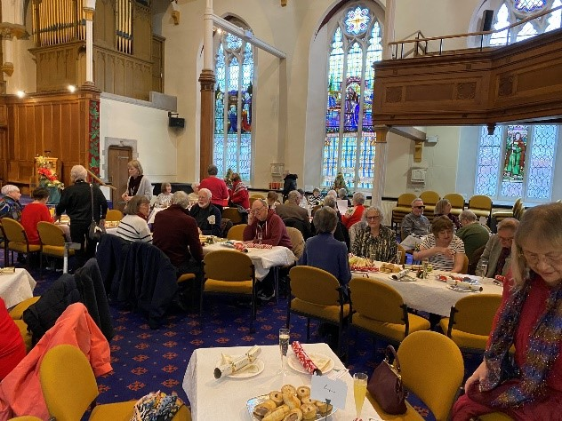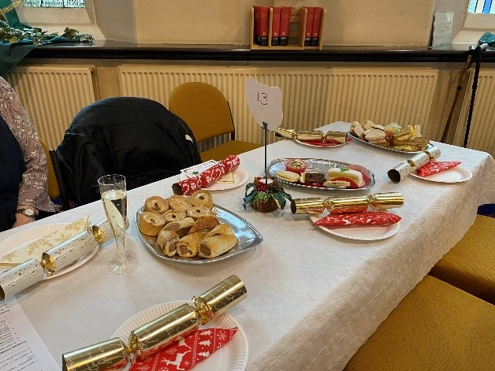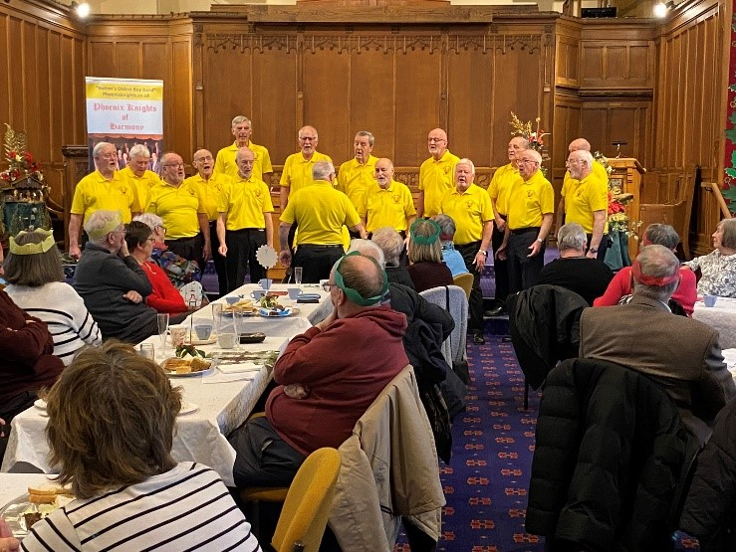

Bolton U3A Reg Charity 1140495 1

Learn, Laugh and Live! <https://u3asites.org.uk/bolton/home>December 2023

Hello friends!

At the end of my second year as Chair of Bolton u3a, I am indebted to my fellow committee members who have all worked tirelessly and put in outstanding work to ensure Bolton u3a runs smoothly and is financially sound. As ever, their knowledge, assistance and enthusiasm has made this a year to remember.

We learned in March that the Bolton Fund had given us £9,794 with the main objective of “establishing more physical/group activities to reduce mental stress and isolation in older people”. Vice-Chair Lynn Gray was instrumental in encouraging me to apply for the funds, so a big Thank You must go to her.

With the funds, we have established line dancing, chair-based exercise and Pilates classes. We have had training in Nordic Walking and purchased specialist Nordic Walking poles to add to our u3a asset list. We have established 3 new coffee and chat groups, making 4 in total, that are proving to be very popular and a valuable recruitment method. We have subsidised a number of trips and outings and advertised Bolton u3a in several local directories. And we have formed partnerships with the GP social prescribing team to provide free memberships to people they refer to us, who may be feeling isolated.

Now a few words on your committee members. During the last year, Liz Robinson was co-opted onto Com-mittee as Business Secretary after Paul Beaumont emigrated. Liz is settling into her role well and has shown she is diligent and conscientious in ensuring we conform to Charity Commission rules and are well managed. Liz is also leading the new Renaissance Art group. Thank You Liz.

David Dean has once again shown himself to be an excellent Treasurer for Bolton u3a, keeping a handle on all our financial matters. In addition, he has been newsletter editor for most of the year. Thank You David.

Alison Dyson, our membership secretary, has had a very busy year handling membership payments and new enquiries, signing up new members, liaising with the Third Age Trust and organising new member events. We now have just over 255 paid-up members (25 have not yet renewed their membership!) and hopefully we will reach 300 in the coming months. Thank You Alison.

Duncan Macpherson, our group leaders’ co-ordinator, has also had a busy year with all these new groups starting. He has been instrumental in forging ahead with the coffee and chat groups we run and is also lead-er, with wife Chris, of our Cinema group. Thank You Duncan.

Janet Thatcher steps down at this AGM after 5 years co-ordinating our venues. Janet is a most conscientious person, offering sound advice and dependability. She will be sorely missed on Committee. Thank You Janet.

Ernest Harper also steps down from Committee this year after 5 years managing front of house. At 92 years young, Ernest is a shining example for those of you who think you’re too old to help out on committee. Where he gets his energy from, I don’t know. Thank You Ernest.

Kathryn Chatwin took on the Publicity role this year and has been busy managing our Facebook group and page, sharing our info with other local groups, and organising outreach events which are all helping our re-cruitment drive. Thank You Kathryn.

Our thanks must also go to Maggy Simms, who manages our websites (old and new) and is our technical go-to person; and to Win Conway, our trusted speaker secretary, who introduced us to some great speakers this year including Dr Antony Sykes and his DIY Surgery talk; and the pharmacist, Stephen Freeborn, and his talk: Keep on Taking the Tablets.

Just recently, we have co-opted Steve Brown and Pauline Treuherz onto committee. I trust you will approve their nomination to join the committee.

With our current groups numbering more than 35, I will leave Duncan to detail our many group leaders, who are also greatly talented and enthusiastic volunteers, and are the backbone of the learning and the fun we have at our meetings, but our heartfelt thanks must go out to them all. Thank You Group Leaders and Thank You to each and every one of our members, who support our groups here at Bolton u3a.

Bolton U3A Reg Charity 1140495 2

Learn, Laugh and Live! <https://u3asites.org.uk/bolton/home>December 2023

Finally, I want to mention some of the external organisations that have supported us in the past year. We were most pleased that the Mayor of Bolton, Councillor Mohammed Ayub, visited us at our speaker meeting in October. We must thank Bolton CVS for providing the Bolton fund grant. Additionally, we received £500 from the Every Mind Matters project to spread information on how to manage our mental wellbeing; and Bol-ton’s Festive Fund supported by the Sir James and Lady Scott Trust, Bolton at Home and Unity 5 provided £135 for a Yuletide treat for our volunteers.

We have also had developed relationships with Bolton Age UK, Bolton Carers Support and the Bolton GP Fed-eration’s social prescribers’ team.

So, to reiterate, this has definitely been a year to remember: a year of new starts, new experiences and new friends. I hope you have enjoyed it as much as I have.

And here’s looking forward to collaborating with you all again in the coming year.

Jeanne Kelly

Chair – Bolton u3a

A reminder that the **new** **Mah** **Jong** **group** begins on Monday 15th January at The Hub, Bolton. It will run alongside the Scrabble and Rummikub. Nine members have already expressed an interest and if you would like more information please email Chris at chris.druck@gmail.com.

**Local** **Digital** **Support**

Would you like to know more about how to use a computer, tablet, smartphone or how to access online ser-vices?

There is now a free help service available through your local library or college.

You can have up to 6 one-hour sessions on a one-to-one basis with a trained mentor. The sessions cover using the internet, social media, seting up emails, downloading Apps, saving money online and buying and selling online.

You can borrow a device to access IT services and access printing facilities.

If you are interested, ask a member of staff at your local library or ring the Digital Help Team on 01204 332853

Bolton U3A Reg Charity 1140495 3

Learn, Laugh and Live! <https://u3asites.org.uk/bolton/home>December 2023

**You** **are** **a** **Veteran!**

The Bolton Guild of Help, supported by the Armed Forces Covenant Fund Trust, has embarked on a year-long project to identify and engage with Bolton’s ex National Servicemen. These are some of the ‘forgotten’ veterans who will now be in their 70s, 80s and 90’s. Some will be living at home and managing well, others might still be at home but with carer support and some might be in care homes.

Our National Servicemen served in some of the bloodiest post World War 2 conflicts including the Korean War and the Suez Crisis. They also served in the Cyprus, Kenyan and Malayan Emergencies as well.

Many were also involved in the Nuclear Testing programmes in the 1950 and 1960’s and, in recognition of their significant contribution to the UK’s nuclear deterrent programme; commemorative medals will be issued to them from the early summer onward. All nuclear test veterans are now being encouraged to ap-ply for this award. Posthumous awards will also be made to next of kin.

The main objective of the project is to offer support to any of those veterans who are in real need or finan-cial difficulties. The Guild is able to offer help for almost anything within reason. In the past we have pro-vided emergency food hampers, white good and furniture, help with heating bills, repairs to mobility aids, clothing and minor household repairs. We can also help with benefits entitlement checks and assist with debt management problems.

We also would like to extend our offer of help to any ex National Servicemen’s widows as well.

Our Project Worker, Jill Webb, is managing the project and she will be supported by our ex Royal Air Force veteran Trustee, Richard Davies.

So, if your father, grandfather or great grandfather did their National Service please contact Jill via e-mail, [jill@boltonguildofhelp.org.uk](mailto:jill@boltonguildofhelp.org.uk) (phone 07515 164810) or Richard via e-mail, [asshawes3@sky.com](mailto:asshawes3@sky.com) Alternatively contact the Guild office Monday to Wednesday on 01204 524858. If you are a care home manager and have any ex National Servicemen living with you please do the same.

The Bolton Guild of Help has been providing support to needy people in the Borough since 1905.

Bolton U3A Reg Charity 1140495 4

Learn, Laugh and Live! <https://u3asites.org.uk/bolton/home>December 2023

**NEWS OF INTEREST GROUP MEETINGS AND ACTIVITIES IN JANUARY 2024**

**ARCHAEOLOGY:**

Every 2nd Thursday. The Zoom link will be sent out shortly before each meeting.

The next meeting is by Zoom on 11th January at 2.00pm, new or 'taster' members welcome. We'll look at the ar-chaeology of our first 'Brexit' - the time when Britain was abandoned to its own devices by Rome, and What Hap-pened Next...... Sign up on Beacon and the link will be sent to you a day or so before the meeting.

**ARTS** **AND** **CRAFT:**

Our next meeting will take place on Tuesday, 9th January at 10.30 at St Andrew and George Church.

**BRIDGE** **GROUP:**

Last session this year is Wednesday 20th December 1330 – 1530 at St Andrew & St George Church. Starts again Wednesday 3rd January.

**CHAIR-BASED** **EXERCISE**

Now meeting every Monday i.e. January 8th, 15th, 22nd and 29th at 4pm for 1 hour at Harwood Methodist Church (old building), Longsight Lane, Harwood, Bolton BL2 3JP. New members welcome. Free parking in church car park.

**CHINESE** **POETRY**

Starts on Wednesday 24th January from 1030-1230 at The Hub. All welcome.

‘Ni Hao’, Chinese Poetry since the Cultural revolution. The group will look at the impact of the Cultural Revolution on the classical model of poetry and how poetry is used as political propaganda.

Next session will be on Wednesday 14th February.

**CINEMA** **GROUP:**

The cinema group will meet on Wednesday 10th January at the Light Cinema in Bolton. The film chosen and time to meet will be emailed to members the weekend before. Any new members wishing to join us please

contact Duncan so that you can be included in the email list.

**CLASSICAL** **CIVILISATION** **(GREECE** **AND** **ROME):**

This month's meeting will be on Thursday 11th January at 1030 am at The Hub. The topic will be *An*

*Archaeological* *Pot-Pourri*. There's lots going on underground and all sorts of discoveries constantly being made -think of Time Team. We'll take a look at a selection

**COFFEE** **AND** **CHAT:**

**Olympus** **restaurant** from 1030am, on Tuesday 2nd January and Tuesday 16th January. **Egerton** at the Globe Café on Tuesday 9 January at 1030

**Heaton** at The Coffee Shop, New Hall Lane, Heaton. Please note that the group will now meet on the 2nd Tuesday of each month so the next meeting is on Tuesday the 9 January at 1030.

**Harwood** at Longsight church hall on Thursday 11th January from 1030 onwards. Everyone welcome.

**CRYPTIC** **CROSSWORDS**:

**Group** **One** will meet on Fridays 5th and 19th January at Olympus restaurant at 2pm.

**New** **Group** **Two** will meet on Tuesdays 2nd and 16th January at Olympus restaurant at 2pm.

**DIGITAL** **PHOTOGRAPHY:**

The group will meet on January 5th at 1030 at The Hub. I’ll have a laptop and large screen for showing photos, so please bring your photos on a pendrive or upload them onto our Flickr account.

On January 19th the group will meet as usual at St. Andrew and St George church at 1030. Please bring ideas for future field trips and meeting topics.

Bolton U3A Reg Charity 1140495 5

Learn, Laugh and Live! <https://u3asites.org.uk/bolton/home>December 2023

**DINING** **GROUP:** **CHRIS** **DRUCK**

The next meeting on Thursday 11th January at 1pm at the Spice Valley Indian Restaurant on Lee Lane in Horwich. The restaurant is on the 125 bus route and has a car park. It is possible to choose a dish with mild or no chilli.

**FAMILY** **HISTORY** **GROUP:**

Next meeting will be on Tuesday 9th January at 2pm at Harwood Library near Morrisons.

Bring a special family photograph you want to talk about. New members welcome.

**ITALIAN** **RENAISSSNCE** **ART:** **businesssecretary@boltonu3a.org.uk**

The group will meet on Tuesday 22rd January from 1030 to 1200 at the Hub. Not sure of the topic just yet, but we shall probably look at least one of the *Big* *Three!* (Da Vinci, Michelangelo, Raphael) Please note that this group is currently oversubscribed.

**LANGUAGE** **AND** **COMMUNICATION:**

Continuing an investigation into *Language* *and* *the* *Brain* and the strange link to music!

**LINE** **DANCING** **chairman@boltonu3a.org.uk**

**NEW** **VENUE** for classes: Triangle Annex, New Church Road, Bolton, Lancashire, BL1 5QP

**For** **Sat** **Nav** **use:** BL1 5SH. Meeting on Friday 12th and 26th January 1030-12noon. Wear loose clothing and no trainers. New members welcome—it’s great fun and good exercise.

**LOCAL** **HISTORY:**

No meeting in January. The next meeting will be a visit to the new Library/museum in the town centre on Wednesday 7th February. Meet at 2.00pm at the entrance to the Library on Le Mans Crescent.

**MAH** **JONG:**

The group will hold their first meeting on Monday 15th January at 1030 at the Hub

**MATHS** **GROUP:**

Our Meeting is on Friday, January 19th at the Hub at 1330pm

We shall work on thinking in 3D. All are welcome.

**MINDFULNESS:**

The group will meet on Zoom on Monday 15th January at 1pm. We’d welcome new members who would like to join us via Zoom—it’s not necessary to have any previous knowledge or experience of mindfulness practice. Anyone interested in joining the group on Zoom should contact Annie.

**MUSIC** **APPRECIATION:**

A one-off special session on the Shostakovich Symphony no 6, in preparation for our visit to the Halle Concert at the Bridgewater Hall, on January 21st.

Bolton U3A Reg Charity 1140495 6

Learn, Laugh and Live! <https://u3asites.org.uk/bolton/home>December 2023

|  |
| --- |
|  |
| **PHILOSOPHY:**  The group will meet on Tuesday 23rd January at 2pm at the Hub. The topic will be the philosophy of Avicenna, Averroes and Thomas Aquinas. |
| **PILATES:**  The group meets on Monday afternoon at 1.30pm until 2.15pm at the Westhoughton Hub on Central Drive, Westhoughton. There will be no meetings on Monday 25th December or Monday 1st January.  The group has room for new members. If you are interested, please contact the group leader. |
| **POETRY** **FOR** **PLEASURE**  Thursday 18th January: 1330-1530 at the Hub.  Any member who happens to be free on any of these occasions would be most welcome to join us. If you would like any further information contact Lynn. |
| **PSYCHOLOGY:**  Tuesday 6th February at 2pm at The Hub  The group has lost its experienced leader as Brenda has moved to Kendal. At the last meeting Brenda encouraged the group to continue by appointing a co-ordinator to arrange topics for future meetings. She encouraged mem-bers to share their experiences and lead a session.  Steve Brown has volunteered to act as coordinator and to lead the next meeting with a discussion about the Psychology of Work. Steve has also been in contact with the Dept of Psychology at the University of Bolton to arrange for a guest expert to attend future meetings of the group. Members are invited to send their ideas for fu-ture discussion to Steve. |
| **QUIZ** **GROUP**:  Next meeting of the Group is 12 January at 2pm at The Hub.  Question Masters will be Patsy & Paul McKee. |
| **READING** **GROUP**:  The group will meet at 1030 on 18th January on Zoom. We will be discussing 'The Windsor Knot', by SJ Bennett. New members welcome so if you like to talk about books and would like to join us, please contact Annie .  If you're not sure you want to join us but would like to come to discuss a specific book one month, again, please contact Annie. |
| **RUMMIKUB:**  Monday 15th January at 1030 at the Hub |
| **SCRABBLE:**  Monday 15th January at 1030 at the Hub. |
| **SINGING** **FOR** **PLEASURE:**  The group will meet on Friday 5th and Friday 19th January at 10.30 am in the Seminar Room at Claremont Church, St George's Road under our Musical Director, Win Conway.  We welcome new members in all voices (Alto, Bass, Soprano, Tenor) who want to enjoy singing with others. Claremont Church is an excellent central venue, on bus routes 125, 501 and 575 about a 5-minute ride from the Interchange. There is ample car parking at NCP Topp Way a short walk from the church. |
| **TOPICAL** **SCIENCE:**  Monday January 15th at 2pm at the Hub.  Topics: Science to look out for in 2024. Thoughts on Heat Pumps. Members are welcome to bring along any items of news that they wish to share with the Group All welcome. |
| Bolton U3A Reg Charity 1140495 7 |

Learn, Laugh and Live! <https://u3asites.org.uk/bolton/home>December 2023

**Bolton** **U3A** **Monthly** **Meetings**

These are held from 1400-1600 on the 4th Friday of every month (except December). At St Andrew & St George United Reform Church, St George’s Road, BL1 2BS. Visitors, for an entry fee of £3 are welcome to attend twice.

The programme of speakers is given below—come along and listen to what they have to say!

**SPEAKERS for 2024**

**JANUARY** **26TH**

**FEBRUARY** **23RD**

**MARCH** **22ND**

**APRIL** **26TH**

**MAY** **24TH**

**JUNE** **28TH**

**JULY** **26TH**

**AUGUST** **23RD**

**SEPTEMBER** **27TH**

**OCTOBER** **25TH**

**NOVEMBER** **22ND**

Bolton U3A

Northerners – A History.

Rivington Terraced Gardens.

The Sixties.

Miss Lydia Becker.

Memsahibs and Their Servants.

To be Announced Later.

My Life with the Lancashire Constabulary.

Billy’s War.

Bedpans and False Teeth.

The Artifacts of Folk Magic.

Annual General Meeting

Reg Charity 1140495

Brian Groom.

Graham Gough.

Frank Vigon

Joanna Williams

Jenny Malin

Mahmood Ahmed.

Paul Atherton

Denise Adlard

Peter Watson

8

Learn, Laugh and Live! <https://u3asites.org.uk/bolton/home>December 2023

|  |  |  |
| --- | --- | --- |
| **Committee** **Members** | | |
| Chair | Jeanne Kelly | [chairman@boltonu3a.org.uk](mailto:chairman@boltonu3a.org.uk) |
| Vice Chair | Lynn Gray | [vicechairman@boltonu3a.org.uk](mailto:vicechairman@boltonu3a.org.uk) |
| Business Secretary | Liz Robinson | [businesssecretary@boltonu3a.org.uk](mailto:businesssecretary@boltonu3a.org.uk) |
| Treasurer | David Dean | [treasurer@boltonu3a.org.uk](mailto:treasurer@boltonu3a.org.uk) |
| Group Leaders’ Coordinator | Vacancy | [groupscoordinator@boltonu3a.org.uk](mailto:groupscoordinator@boltonu3a.org.uk) |
| Newsletter Editor | Pauline Treuherz | newslettereditor@boltonu3a.org.uk |
| Membership Secretary | Alison Dyson | [u3abolton@hotmail.co.uk](mailto:u3abolton@hotmail.co.uk) |
| Venues Coordinator | Janet Thatcher | venuescoordinator@boltonu3a.org.uk |

**Membership** **Enquiries**

Alison Dyson Email: u3abolton@hotmail.co.uk Change of address, email or phone details?

Please let Alison know for our records.

**Help** **us** **stay** **informed**

If you know of a member who has been ill, or is recently deceased, please inform the relevant group leader, in order that the information can be circulated appropriately. Please leave a phone number if you want a Group Leader to respond to

a phone message.

**Newsletter** **News**

Please send contributions to: newslettereditor@boltonu3a.org.uk

Deadline: Friday 19 January 2024

|  |  |
| --- | --- |
| We are always happy to support new groups and activities!  E-mail: [groupscoordinator@boltonu3a.org.uk](mailto:graoupscoordinator@boltonu3a.org.uk) | Visit our Website:  <https://u3asites.org.uk/bolton/home> |

Bolton U3A Reg Charity 1140495 9